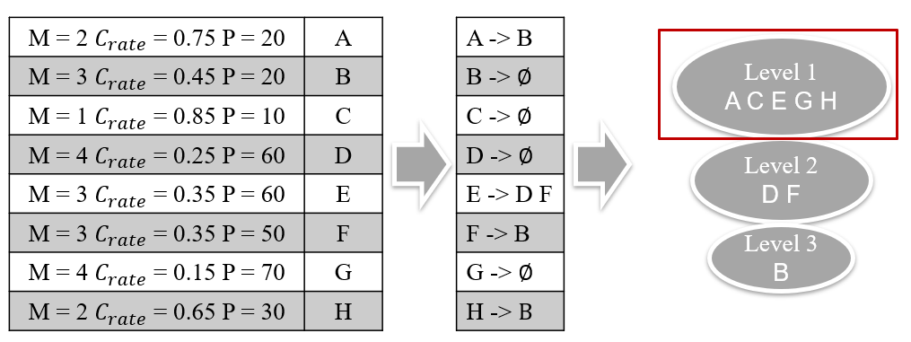

Figure 10. An example of non-dominated sorting